Names: Bello, Juluis Marco, Cabantring,Andree, Romero,Kirk Tyler | Date: 09/05/2025
Lesson 4: Introduction to Git
In this lesson, we will be learning git basics: how to create a repository, make commits, create branches, and merge changes, all within Visual Studio Code.
- Create a new folder on your desktop named lastname-sample. In Visual Studio Code, open this folder.
- Open your terminal in VS Code by clicking Terminal > New Terminal or pressing Ctrl + ` on your keyboard.
- In the terminal, type: git --version. Press Enter.
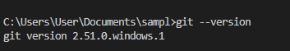
- Set up your git profile name by typing the following command: git config --global user.name “Your Name Here”. Press enter to run the command.
- Next, set up your email by typing the following command: git config --global user.email “yourexample@email.com”. Press enter to run the command. (Note: Since we are practicing, you may use a fake email.)
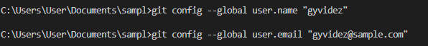
- In the left sidebar of VSC, click the source control icon ().
- Then, click Initialize Repository.
- After Initialization, go back to the Explorer () tab of VSC.
- In your folder, create a new file called: hellogit.txt
- Inside the file, type the following: Hello, Git! Our names are [names]! Save the file.
- Return to Source Control. Your new file, hellogit.txt, should be present there, under Changes.
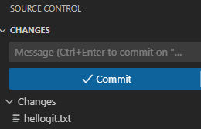
- Hover over the file, then click the + (stage changes) button.
- At the top, on the Message area, type a commit message: “First Commit.”
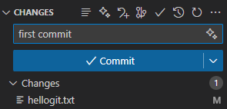
Activity 1: Git Practice
Instructions: Follow the steps given below. For every instruction, attach a screenshot of the relevant windows and areas on your screen. Refer to the lesson above for reference. (2 pts. each)
A. Changes and Commits.
1. Open hellogit.txt. Type the following changes, filling them up with your own writing and info. One for each group member.
My name is: x
For breakfast today, I had:
The programming languages I know are: x, x, x…
What I like about programming is: x
What I dislike about programming is: x
Screenshot: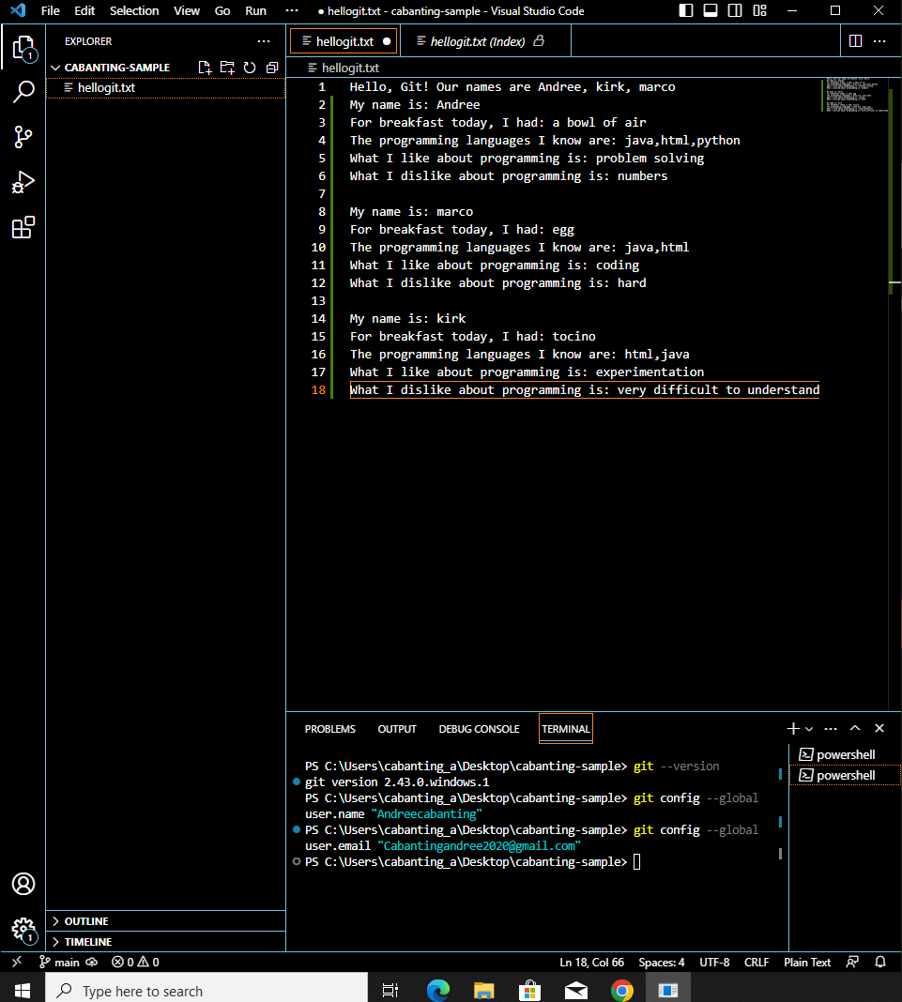
2. Commit your changes. Write your custom message.
Screenshot:
B. Branch Practice
- Look at the bottom-left corner in VS Code. You’ll see the current branch you’re working on, usually highlighted in blue. By default, this is set to main.
- Click on the main branch.
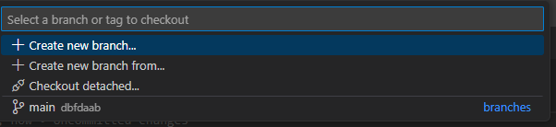
- A popup will appear on the top of your window. There, create a new branch. Name it branch-hello.
Screenshot: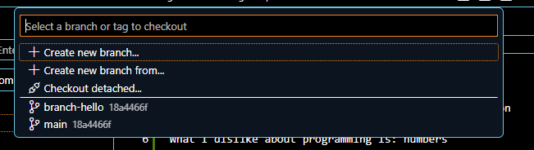
- Make sure you are working on the branch-hello branch. To double-check, you can look at the bottom left corner of VSC again.
- Make any change to hellogit.txt.
Screenshot: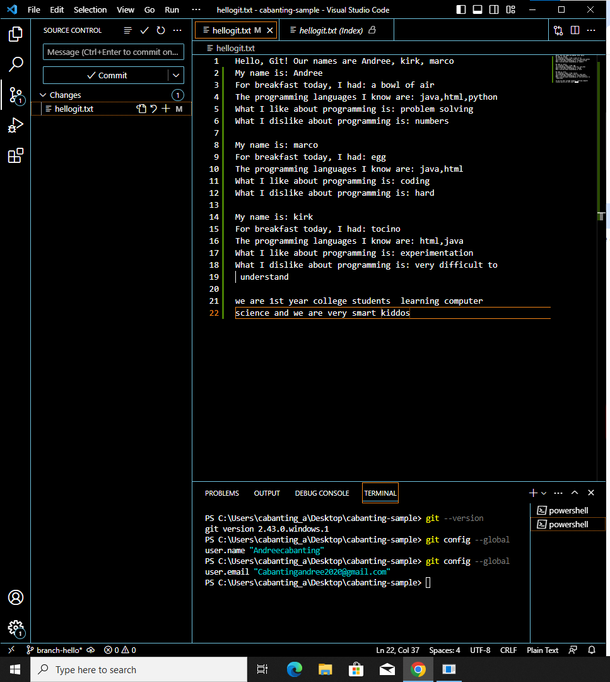
- Save and commit with a new message indicating that you are committing from a new branch.
Screenshot: 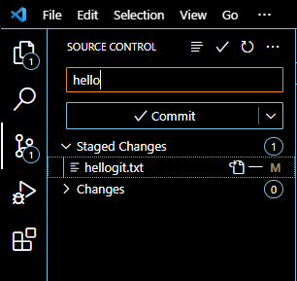
- Switch back to main. What changes did you observe in hellogit?
Answer:it shows info on the terminal reading git show
- While currently on main, open the Command Palette by pressing Ctrl + Shift + P.
- Type Git: Merge Branch. Click branch-hello.
Screenshot: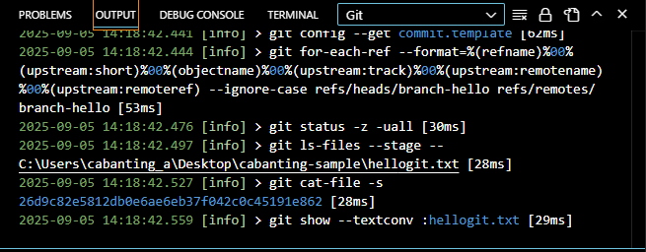
- What changes did you observe in hellogit?
Answer:it shoes another info on the output
C. Merge Conflicts
- Switch to main. Create any new line on hellogit.
Screenshot: 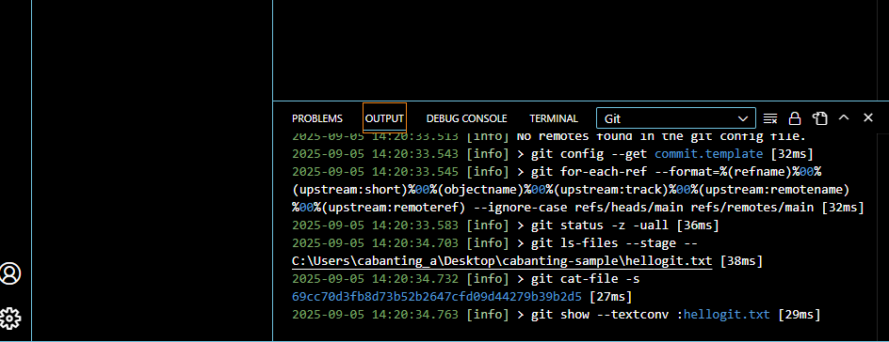
- Commit this change with the appropriate message.
Screenshot: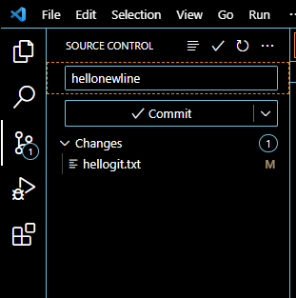
- Switch back to branch-hello. On this branch, edit the new line you created on hellogit. For example, if you edited line 11, edit the same line here. Make any change, then commit.
Screenshot: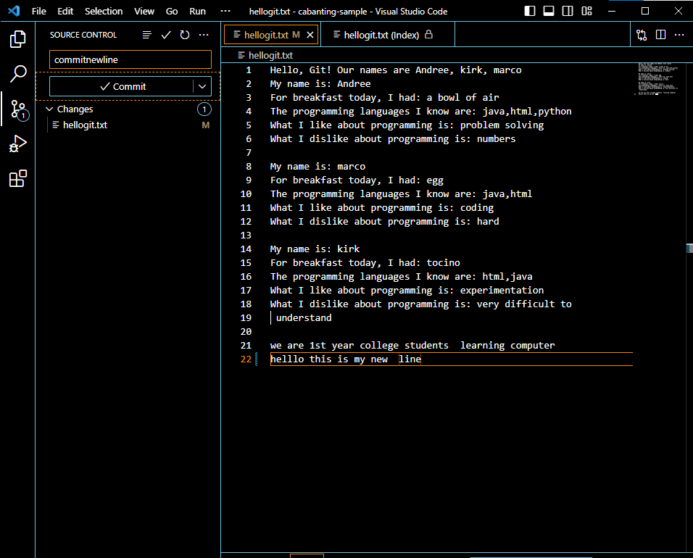
- Switch back to main, then perform a merge.
- Go back to hellogit.txt. What appears?
Screenshot: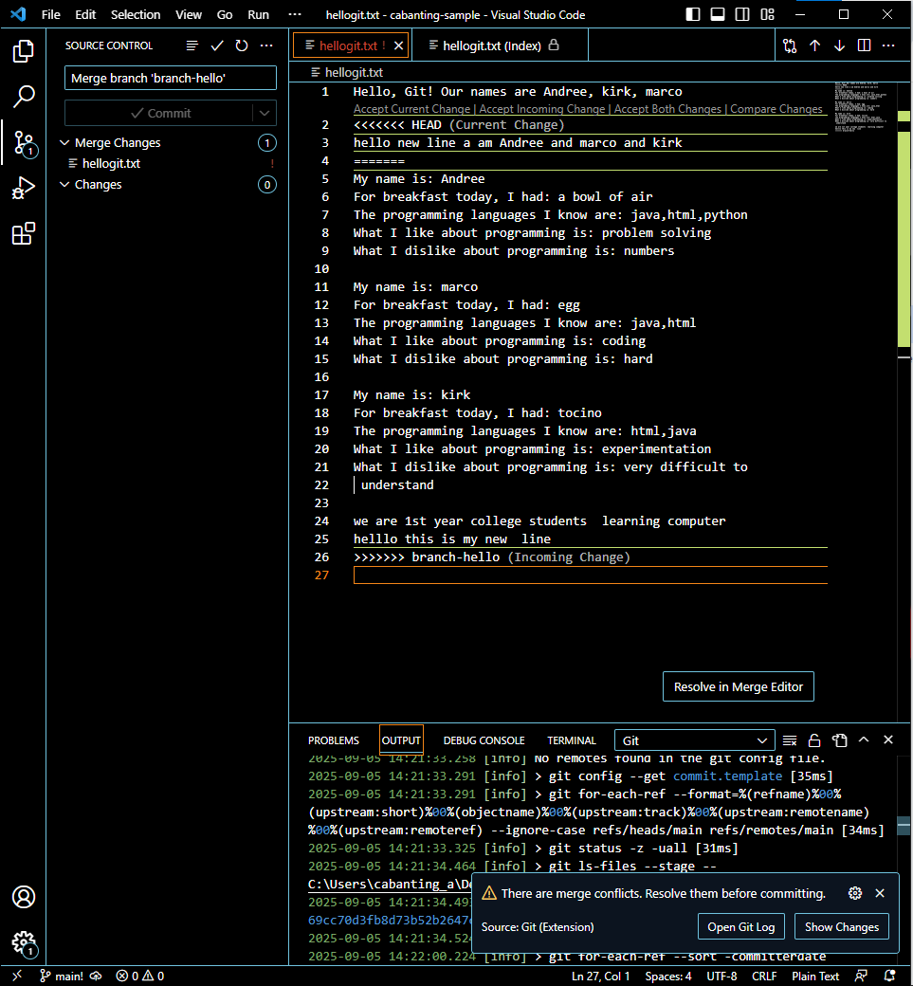

C. Short Essay: In your own words, answer the following questions. Work will be checked for AI usage. Any answers detected to have used AI assistance in writing will be considered invalid and given a mark of 0 (5 pts each)
1. Research and read up on Git. What is its history, its purpose, and its usage?
- It was Created in 2005 by linus Torvalds he also made linus. After the linus community lost access to a private version control tool called BitKeeper. Its purpose is to track changes in code and manage collaboration to different developer. It is used by developers for collaboration on large projects to platforms like GitHub and GitLab.
2. Explain and define each of the git commands you performed and their overall purpose.
-Git Config: This ids used to set up Git settings such as the username and gmail.
-Git merge: This is used to combine the changes from one branch into another.
3. why do you, as a future UI/UX developer, need to know and understand git?
- As a UI/UX in the future, the importance or need to understand git is because git is free and open source. Meaning you can get other people opinions or improvement for your design.
4. Why do you think Git has become essential in software development and web design? What problems does it solve?
-It stops fights by letting multiple people work on the same project at the same time. It keeps a complete history of changes, so mistakes can be undone easily. It makes collaboration across teams and locations better.

